**To perform assignments 1 to 5, refer to the table structures in Figure 1-5 and the table listings in Appendix A.**

**1. Which tables and fields would you access to determine which book titles have been  
purchased by a customer and when the order shipped?**

Table: ORDERS

Field: Orderdate = purchased by customer & Shipdate = when the order was shipped

**2. How would you determine which orders have not yet been shipped to the customer?**

To determine which orders have not yet been shipped to the customer you check the ORDERS table and look at the (null) values in the Shipdate field

**3. If management needed to determine which book category generated the most sales in April 2009, which tables and fields would they consult to derive this information?**

The fields that management would need to consult is the Orderdate field from the ORDERS table and filter the values for the Orderdate field to April 2009, then navigate to the Quantity field in the ORDERITEMS table and the Category field in the BOOKS table, then compare the value of the Quantity field for each corresponding Category field.

**4. Explain how you would determine how much profit was generated from orders placed in April 2009.**

From the Orderdate field from the ORDERS table, one would need to filter the values for the Orderdate field to April 2009, then use the fields: Quantity and Paideach from the ORDERITEMS table, Cost, Retail, and Discount field from the BOOKS table, Minretail and Maxretail field from the PROMOTIONS table and calculate the profit using all those factors(fields).

**5. If a customer inquired about a book written in 2003 by an author named Thompson, which access path (tables and fields) would you need to follow to find the list of books meeting the customer’s request?**

The access path to find the list of books meeting the customer’s request:

Tables: CUSTOMERS > ORDERS > ORDERITEMS > BOOKS > Pubdate (field)(to filter Pubdate value to 2003) > BOOKAUTHOR > AUTHOR > Lname/Fname (field)(to filter value to authorname)

**In assignments 6 to 10, create a simple E-R model depicting entities and relationship lines for each data scenario.**

**6. A college needs to track placement test scores for incoming students. Each student can take a variety of tests, including English and math. Some students are required to take placement tests because of previous coursework.**

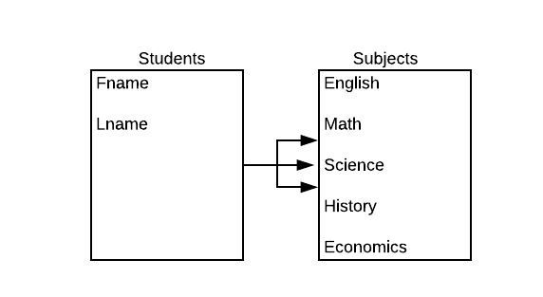

**7. Every employee in a company is assigned to one department. Every department can  
contain many employees.**

**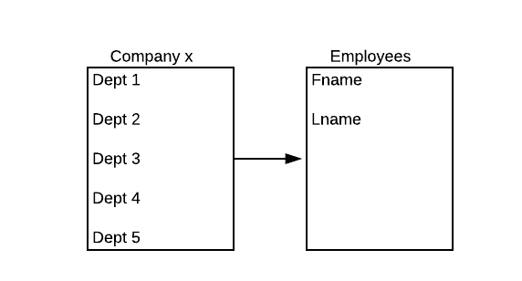  
8. A movie megaplex needs to collect movie attendance data. The company maintains 16 theaters in a single location. Each movie offered can be shown in one or more of the  
available theaters and is typically scheduled for three to six showings in a day. The movies are rotated through the theaters to ensure that each is shown in one of the stadium-seating theaters at least once.**

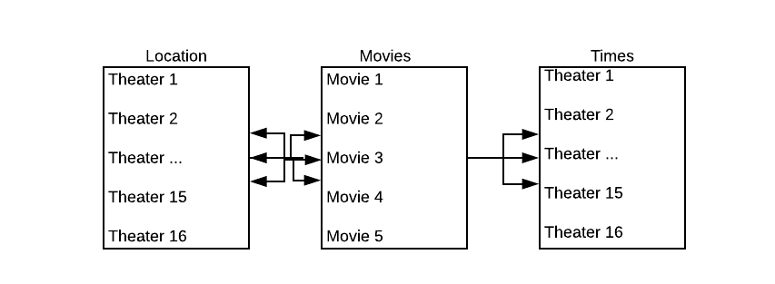

**9. An online retailer of coffee beans maintains a long list of unique coffee flavors. The  
company purchases beans from a number of suppliers; however, each specific flavor of  
coffee is purchased from only a single supplier. Many of the customers are repeat  
purchasers and typically order at least five flavors of beans in each order.**

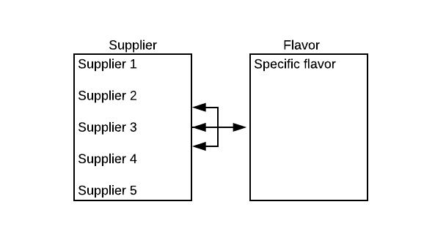

**10. Data for an information technology conference needs to be collected. The conference has a variety of sessions scheduled over a two-day period. All attendees must register for the sessions they plan to attend. Some speakers are presenting only one session, whereas others are handling multiple sessions. Each session has only one speaker.**

